# Video Recordings 1.Download and play a video recording **RTc0bf3f7fd3972c6d897e6ad3f975c558**

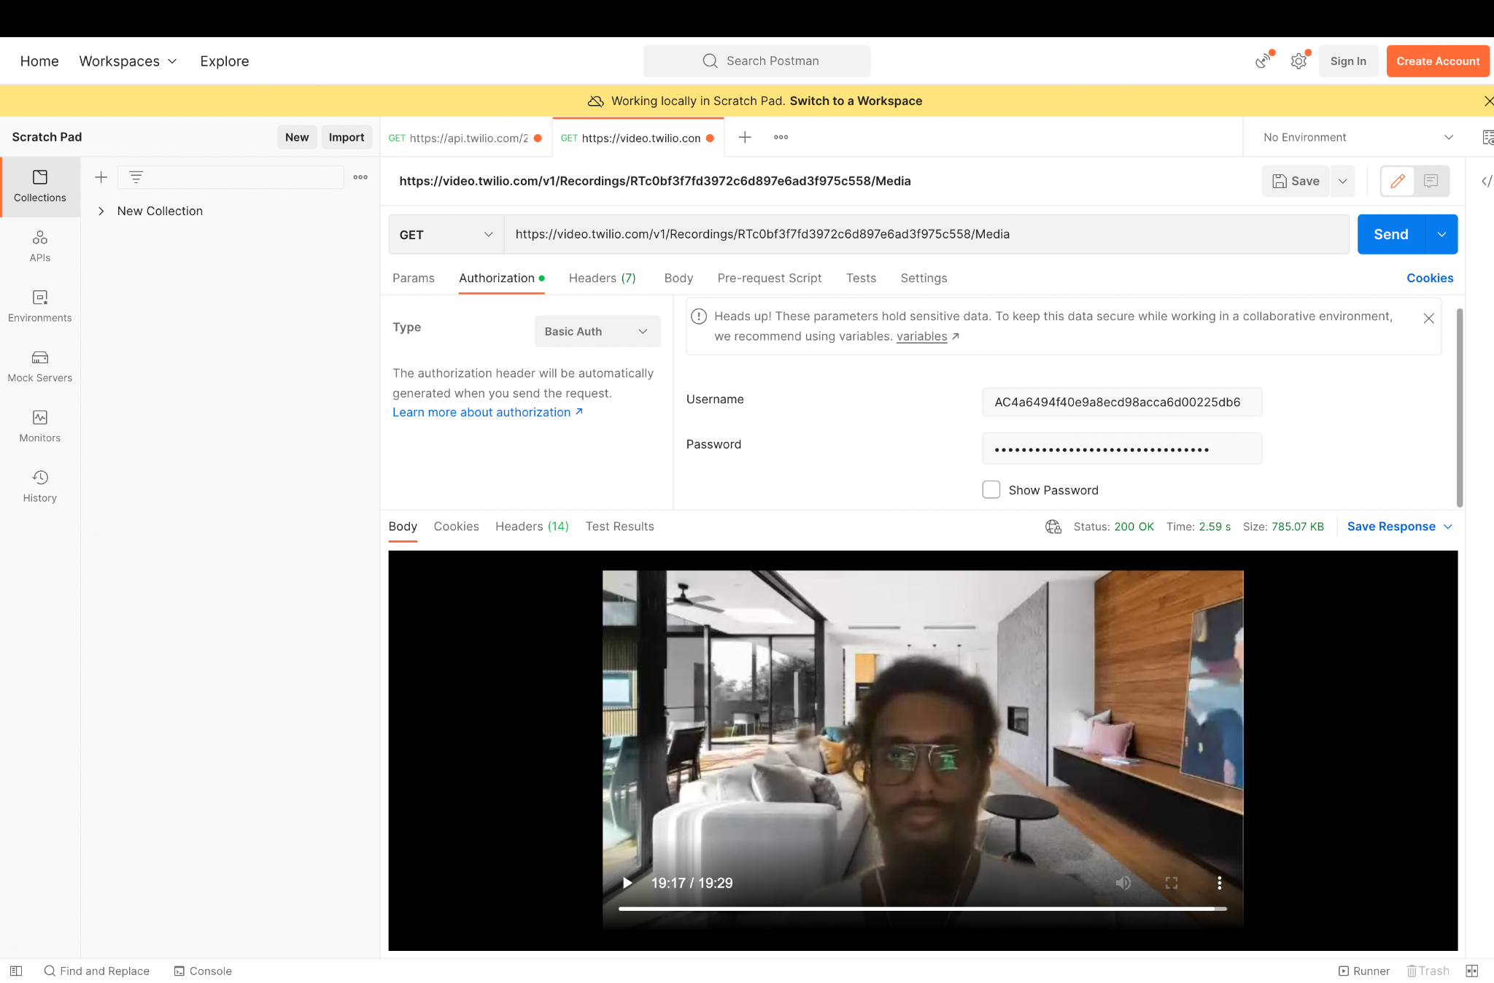

3.Audio file playback **RT351a282858b6fc044f3d8a1e9f0aa64d**  
